 | 35.2 Addon - Bforartists Presentation Slider
Table of content
Bforartists Presentation Slider 1
Operators 1
Slides 1
Previous 2
Next 2
Loop Animation 2
Hide Interface 2
Use 2
Scenes as “Slides” 2
Animated Transitions 3

Bforartists Presentation Slider

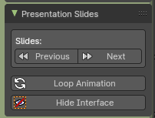
This addon is optional and deactivated by default.
This adds a Presentations Slides panel to the View tab in the sidebar of 3D View Editor. This then allows to use buttons to go to next scene or previous scene as if they were presentation slides.
Note
To activate/deactivate an addon, go to Edit – Preferences – Addons tab – and untick any activated addons.
If you’d like to keep your addons for future use, you can either save the preferences, or activate them on demand per workspace in the workspace settings in the property shelf.

Operators

This addon adds a hook (app handler) when using the slides buttons which then allows the animation timeline to stop when it reaches the end frame - to get default looping timeline animation, press the Loop Animation button in the Addon panel.
Note
Works best when playback is on Play Every Frame in the Option panel of the Timeline Editor.

Slides
This group of buttons controls the slides operations.

Note
These buttons switch to the Scene defined by alphabetical order of the Scene names.

Previous
Switch to the previous scene, then playback the animation timeline then stop on the last frame. When at the first scene, it will then go to the last scene.

Next
Switch to the next scene, then playback the animation timeline then stop on the last frame. When at the last scene, it will then go to the first scene.

Loop Animation
Removes the hook to playback the timeline animation once, and resets to playback to loop the animation timeline per default. This will also playback the animation.

Hide Interface
This adds an additional operator to hide all toolshelves if the header is showing. This will also maximize the 3D View and hide all overlays. Ideal for having a fullscreen without overriding the operating system desktop and allowing a quick switch to show/hide the interface for tutorial presentations.

Use

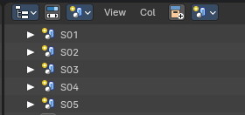
Scenes as “Slides”
To use the addon, organize your presentation content in Scene containers in the Outliner Editor – and create new slides using Linked Copy of a Scene or New Scenes. Every “presentation slide” is a Scene container.

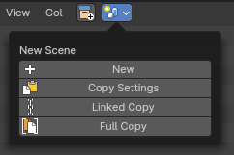
Name the Scenes in alphabetical or numerical order for the sequence of “slides” you would like to present.

For best user experience, switch the Outliner Editor to Scene mode to manage your “slides”.

Animated Transitions
For animated transitions: animate the camera and scene content within the timeline start and end frames. When the first Scene is ready, Link Copy or create a New Scene from the first Scene, then change the second Scene’s timeline to start from the previous Scene’s end frame, camera position, and/or linked collections.

Example:
Scene 01 – set timeline from 0-30 frames: animate camera from position A to B
Scene 02 – set timeline from 30-60 frames: animate camera from position B to C
Scene 03 – set timeline from 60-90 frames: animate camera from position C to D

